Our balancing game will mostly focus on the middle aged woman demographic because during our studies we have found out that middle aged women are most likely to play a non violent, puzzle game on a mobile device.

This pie chart shows the age groups of people that play mobile games.

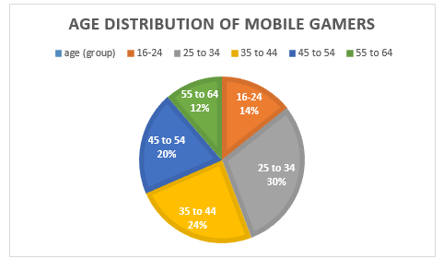

In this chart we can see that women dominate the market for casual games such as Candy Crush and Solitaire

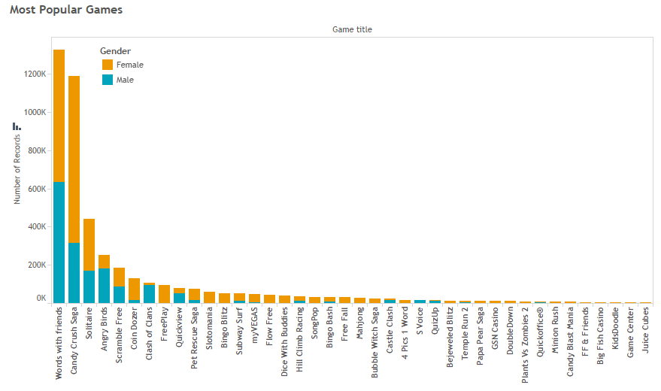

In this comparison we can see that women are much more likely to play a non violent game rather than a violent one.

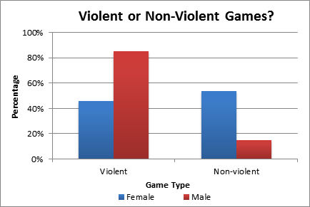

http://usabilitynews.org/video-games-males-prefer-violence-while-females-prefer-social/<http://www.realitymine.com/myth-busting-mobile-gaming-demographics/>

<http://essentialfacts.theesa.com/Essential-Facts-2016.pdf>

http://usabilitynews.org/video-games-males-prefer-violence-while-females-prefer-social/